Diagnosis and treatment of wandering spleen in children: A novel splenopexy technique

Jun Shu , Jun Yang , Hongqiang Bian , Fei Peng , Ji Wang
Department of General Surgery, Wuhan Children’s Hospital, Tongji Medical College, Huazhong University of Science & Technology, Wuhan 430016, Hubei, China
Corresponding Author: Jun Yang, E-mail:yjun201602@163.com

Ethical approval
This research protocol was rigorously reviewed and approved by the Ethics Committee of Wuhan Children’s Hospital (Wuhan Maternal and Child Healthcare Hospital), Tongji Medical College, Huazhong University of Science & Technology( registration number 2025R156-E01).

Abstract
Objective: To examine clinical diagnostic and therapeutic approaches for pediatric wandering spleen and assess the feasibility of a novel splenopexy technique.
Methods: A retrospective analysis was conducted on the medical records of five pediatric patients diagnosed with wandering spleen who underwent treatment at our hospital between May 1, 2015, and May 1, 2026. All patients underwent surgical intervention and received postoperative follow-up. Diagnostic approaches and surgical techniques were systematically documented.
Results: There were 2 females and 3 males, with ages ranging from 2 years 9 months to 13 years 1 month at initial presentation. Four patients had experienced at least one earlier symptomatic episode that did not result in splenic surgery; in three of these the mean interval between initial presentation and splenic surgery was 32 months, whereas the remaining patient had been managed as acute gastritis at another institution one week before presentation. The predominant clinical manifestations were abdominal pain and vomiting. Ultrasound and computed tomography (CT) confirmed splenic ectopia, torsion of the splenic pedicle, ischemic infarction or necrosis of the splenic parenchyma, and compromise of adjacent organs. Three patients underwent open total splenectomy for splenic infarction or necrosis. One patient received laparoscopic partial splenectomy combined with splenopexy for partial infarction; however, recurrence occurred one month postoperatively, necessitating a secondary procedure—laparoscopic total splenectomy with autologous splenic tissue transplantation. The remaining patient underwent open surgical repair of gastric perforation complicated by wandering spleen, employing a reinforced suture fixation technique for the superior and inferior splenic poles. All four patients undergoing total splenectomy demonstrated significantly elevated postoperative platelet counts. At the most recent follow-up, 13 months after surgery, the patient treated with reinforced splenopexy remained asymptomatic with the spleen in a normal anatomical position.
Conclusion: Imaging examinations are essential for the diagnosis of pediatric wandering spleen. Early splenopexy is recommended upon diagnosis to prevent splenic torsion, necrosis, and adjacent organ injury. The reinforced suture fixation technique for the superior and inferior splenic poles demonstrates safety and feasibility. This approach could be considered for giant wandering spleen; however, its efficacy requires further clinical validation.
Keywords: Wandering spleen, Splenopexy, Splenic torsion, Children

1. Introduction
Wandering spleen represents a rare yet clinically significant condition characterized by abnormal splenic displacement due to inadequate development or complete absence of the intra-abdominal supporting ligaments [1]. Although frequently asymptomatic for prolonged periods, the potential for torsion around the slender vascular pedicle constitutes a critical clinical concern [2]. Splenic torsion may result in compromised arteriovenous blood flow, leading to splenic congestion and ischemia; if left untreated, this can progress to infarction [3]. The decision between splenectomy and splenopexy is contingent upon splenic viability, with splenopexy increasingly favored in pediatric populations without evidence of infarction. This study synthesizes diagnostic and therapeutic experiences derived from five pediatric cases of wandering spleen. It aims to contribute to the clinical evidence base for managing this rare condition and to propose a novel splenopexy technique.

- Methods
2.1. Retrospective study
This study conducted a retrospective analysis of five cases of wandering spleen surgically managed at our institution between May 1, 2015, and May 1, 2026, with the objective of systematically summarizing the clinical diagnostic and therapeutic approaches.
A retrospective analysis was conducted on the medical records of five pediatric patients, encompassing demographic characteristics, clinical manifestations, laboratory findings, imaging results, surgical techniques, and outcome data. Follow-up assessments were performed via outpatient visits and telephonic follow-ups. Postoperative complications, including overwhelming post-splenectomy infection (OPSI), thromboembolic events (arterial and venous), and pulmonary hypertension, were meticulously documented and analyzed. Additionally, the efficacy of splenopexy, splenic perfusion restoration, and recurrence rates post-fixation were evaluated. Postoperative surveillance of splenic position and perfusion was performed at regular intervals using abdominal ultrasonography or CT.

2.2. Statistical analyses
Given the limited sample size, we employed descriptive statistics for data analysis and summarized the results in tabular format for clarity. All data management procedures were conducted using IBM SPSS Statistics (Version 26.0).

3. Case histories
3.1. Patient 1
A 3-year-and-9-month-old boy was admitted with a 2-day history of abdominal pain. Abdominal ultrasonography revealed an ectopically positioned spleen exhibiting abnormal mobility, although splenic perfusion remained intact. Following 5 days of symptomatic supportive management—comprising fluid resuscitation, gastrointestinal decompression, and postural maneuvers—the abdominal pain markedly resolved. The family was counseled on the necessity of exploratory surgery to prevent splenic torsion and necrosis; however, they declined surgical intervention and elected for discharge against medical advice form. Sixteen months later, the patient was readmitted with a 1-day history of abdominal pain accompanied by fever. Abdominal CT confirmed wandering spleen with torsion of the splenic pedicle and splenic infarction. Due to the development of splenic necrosis, an emergency total splenectomy was performed.

3.2. Patient 2
A 5.5-year-old girl was admitted with a 2-day history of abdominal pain. Enhanced CT demonstrated a wandering spleen complicated by splenic pedicle torsion, with preserved splenic parenchymal enhancement. Surgical intervention was strongly indicated to mitigate potential complications associated with torsion; however, the patient's family declined and elected for conservative management. Following 7 days of conservative treatment, symptoms resolved spontaneously, and the patient was discharged. Nineteen months later, she was readmitted presenting with a 1-day history of abdominal pain. Repeat CT examination confirmed recurrent wandering spleen with splenic pedicle torsion and resultant splenic infarction (Fig. 1). Laparoscopic exploration was undertaken. Owing to the substantial splenic size and consequent technical difficulties encountered during laparoscopy, the procedure was converted to an open approach, and a total splenectomy was performed (Fig. 2).

3.3. Patient 3
A 4.5-year-old girl was admitted with a 1-day history of abdominal pain and vomiting. Ultrasonographic examination revealed an ectopic spleen with significant gastrectasis. Although surgical intervention was indicated, the family declined. Following 6 days of conservative management, symptomatic improvement occurred, and the patient was discharged. Twenty-six months later, she was readmitted with a 2-day history of recurrent abdominal pain and vomiting. CT imaging revealed torsion of both the gastric and splenic pedicles accompanied by significant gastrectasis and splenic malposition. However, splenic enhancement remained well-defined without evidence of infarction (Fig. 3). The family again opted for conservative treatment; symptoms resolved after 5 days, leading to discharge. Thirty-six months later, she was readmitted with a 9-day history of intermittent abdominal pain. CT revealed a wandering spleen exhibiting partial infarction, measuring 17.3 cm in length and 7.6 cm in width (Fig. 4). Consent for surgical intervention was obtained. Laparoscopic partial splenectomy with splenopexy was performed. The procedure involved resection of necrotic splenic parenchyma and creation of a subperitoneal pouch via a longitudinal incision in the left upper quadrant peritoneum. Owing to the spleen's substantial size, complete accommodation within the pouch was unfeasible; consequently, the spleen was repositioned and affixed using 5-0 silk sutures—securing the superior pole to the diaphragm and the inferior pole to the lateral peritoneum. Hem-o-lock clips were applied to augment fixation. Postoperative CT at one week confirmed restoration of normal splenic positioning (Fig. 5), and the patient was discharged. One month later, readmission occurred due to a 2-day history of abdominal pain. CT revealed recurrent wandering spleen with an aberrant splenic position, measuring 16.6 cm in length and 7.6 cm in width. Concurrently, the pancreatic body and tail exhibited anteromedial rotation (Fig. 6). The patient subsequently underwent total splenectomy with autologous splenic tissue transplantation: the resected spleen was sectioned into 3 cm-thick slices, implanted within the greater omentum, and surgically fixed.

3.4. Patient 4
A 2-year-and-9-month-old boy was admitted with a 2 hours history of abdominal distension. Outpatient non-contrast abdominal CT revealed marked gastrectasia accompanied by wandering spleen and splenic pedicle torsion (Fig. 7). Post-admission contrast-enhanced CT demonstrated gastrointestinal perforation with extensive peritoneal and pelvic effusion. Concurrent gastric volvulus with wandering spleen was identified; the spleen exhibited uniform enhancement without evidence of infarction, measuring 8.4 cm in length and 3.7 cm in width, with the pancreas positioned anterior and to the right of the stomach (Fig. 8). Notably, these two CT examinations (non-contrast and contrast-enhanced) were performed within a remarkably brief interval of merely 1.5 hours. The child subsequently underwent emergency laparotomy. Intraoperative exploration revealed a substantial volume of bilious turbid fluid. Gastric volvulus had occurred along the mesenteric axis, resulting in cephalad displacement of the pylorus and duodenum; the pylorus was clearly positioned superiorly and leftward of the gastric cardia. Following reduction of the gastric volvulus, a 2 cm perforation was identified on the posterior wall of the gastric antrum, necessitating surgical repair (Fig. 9). Intraoperatively, the spleen was observed to be located in the left mid-abdomen, retained solely by its pedicle without additional ligamentous attachments. The spleen was repositioned into the splenic fossa within the left upper quadrant. The superior pole was sutured and fixed to the left diaphragmatic surface, while the inferior pole was sutured and secured to the left lateral abdominal wall. The splenopexy technique was performed as follows: absorbable hemostatic gauze was applied to both the diaphragmatic and visceral surfaces of the superior pole. Utilizing a 2-0 non-absorbable silk suture, the needle was introduced through the hemostatic gauze on the splenic visceral surface, traversed the full thickness of the splenic parenchyma, and exited through the hemostatic gauze on the diaphragmatic surface. The needle was then reinserted, passed through the diaphragmatic muscle, repassed through the hemostatic gauze on the diaphragmatic surface, penetrated the entire splenic thickness, and emerged through the hemostatic gauze on the visceral surface, where the suture was tied. The inferior pole was similarly affixed to the lateral abdominal wall (Fig. 10).
3.5. Patient 5
A 13-year-and-1-month-old boy (body weight 45 kg, height 155 cm) was admitted with an 18-hour history of persistent periumbilical abdominal pain, without fever, vomiting, or diarrhea. One week previously he had been hospitalized for four days at a local hospital and managed as acute gastritis, with resolution of symptoms. He denied abdominal trauma and recent strenuous exercise. On admission his temperature was 36.3 °C, heart rate 100 beats/min, and blood pressure 113/67 mmHg. Abdominal examination demonstrated guarding, generalized tenderness that was most pronounced in the lower abdomen, rebound tenderness, and a palpable mobile firm mass; shifting dullness was negative and bowel sounds were normal. Laboratory investigations revealed leukocytosis (white blood cell count 24.20×109/L; neutrophils 19.24×109/L, 79.5%), a markedly elevated high-sensitivity C-reactive protein of 117 mg/L, and a platelet count within the normal range. Coagulation studies showed a prothrombin time of 13.7 s, an international normalized ratio of 1.20, a fibrinogen concentration of 5.78 g/L, and a D-dimer of 1.91 mg/L FEU. Non-contrast abdominopelvic CT demonstrated an enlarged spleen with an irregular contour and heterogeneous parenchymal density located in the anterior lower abdomen and pelvis, a whirl sign produced by the spiraling splenic vessels in the left abdomen, perisplenic fat stranding and exudation, splenic vessels encircling the splenic flexure of the colon with focal colonic compression, segmental bowel wall thickening, and perihepatic, perisplenic and pelvic free fluid; the pancreas and both kidneys were unremarkable (Fig. 11). Emergency laparotomy was performed approximately 2.5 hours after the CT examination through a left transrectus incision. The spleen was found lying free in the mid-to-lower abdomen, enlarged and congested with a dark purple discoloration, and the splenic pedicle was twisted through approximately 720°, with a portion of the greater omentum adherent to the splenic surface (Fig. 12). The pedicle was detorsed; however, the parenchyma failed to reperfuse and was judged non-viable. Total splenectomy was therefore performed: the splenic pedicle was divided between clamps and the stump transfixed, and the splenic artery was separately exposed and doubly ligated. The operative time was 81 minutes and the estimated intraoperative blood loss was 10 mL. The postoperative course was uneventful. The white blood cell count decreased to 13.13×109/L on the first postoperative day, and the platelet count rose to 918×109/L by the ninth postoperative day, for which oral dipyridamole was administered. At the most recent follow-up 5 months after surgery the child was asymptomatic, with no evidence of overwhelming post-splenectomy infection or thromboembolic complications.

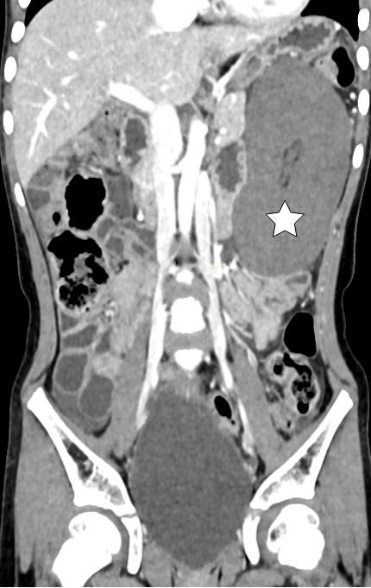
Fig. 1. The second admission CT scan of Case 2 demonstrated a wandering spleen complicated by splenic pedicle torsion and splenic infarction (white star).

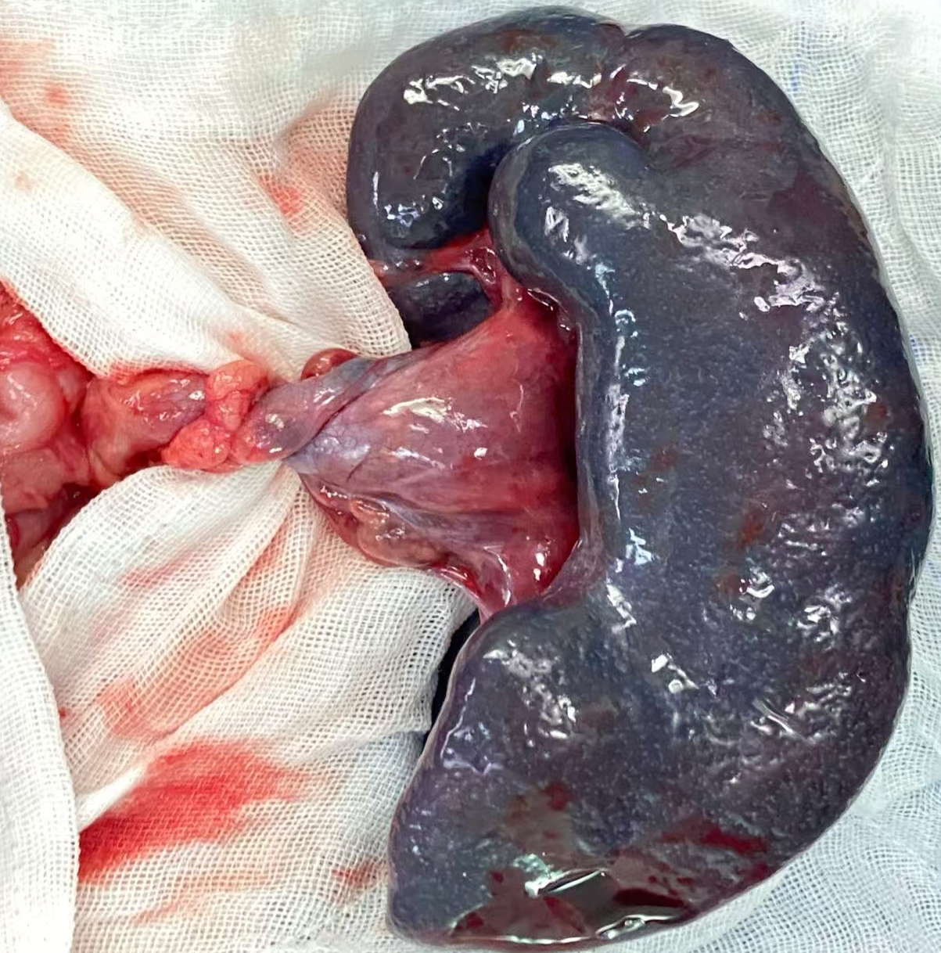
Fig. 2. Infarct of spleen and torsion of the splenic pedicle in Case 2.

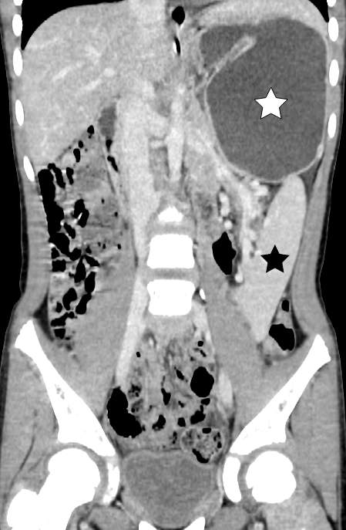
Fig. 3. The second admission CT scan of Case 3 revealed gastric volvulus accompanied by significant gastrectasis (white star) and splenic malposition (black star). However, splenic enhancement remained well-defined without evidence of infarction.
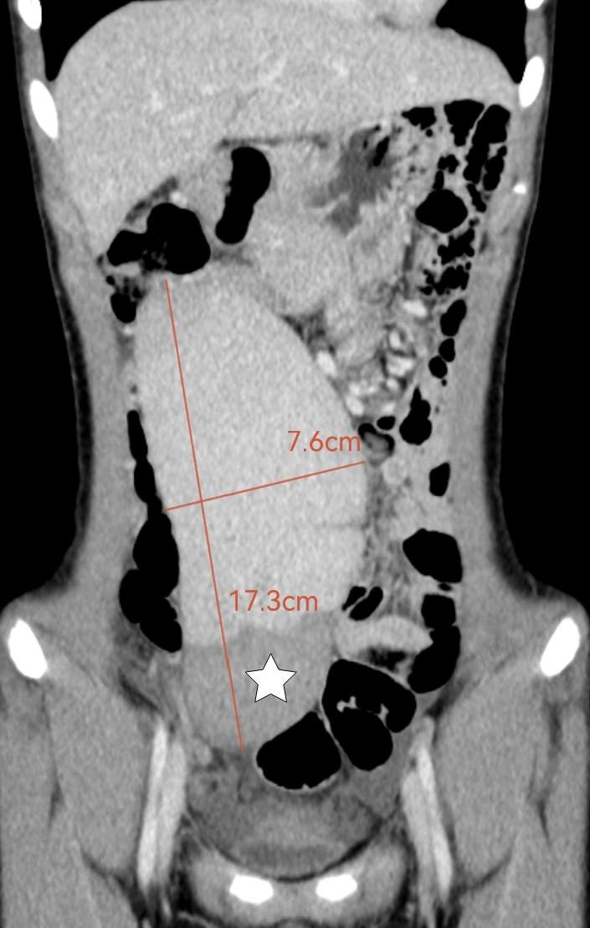
Fig. 4. The third admission CT scan of Case 3 revealed a wandering spleen exhibiting partial infarction (white star), measuring 17.3 cm in length and 7.6 cm in width.
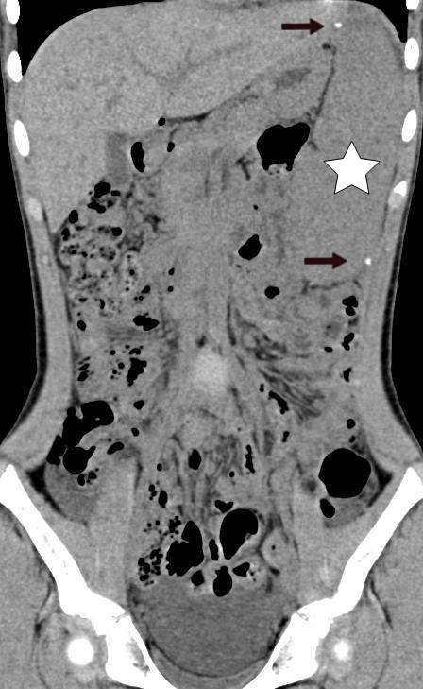
Fig. 5. Postoperative CT scan at one week of Case 3 revealed normal splenic position (white star), with a Hem-o-lock vascular clip evident at both the upper and lower poles (black arrow).

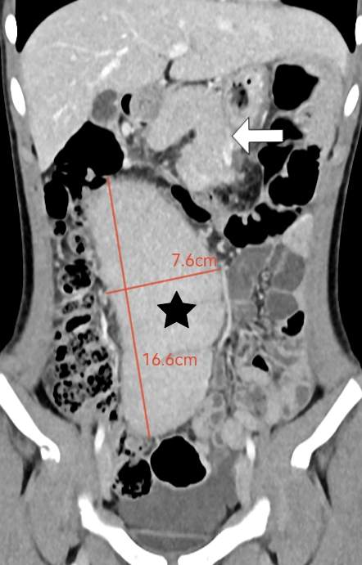
Fig. 6. The fourth admission CT scan of Case 3 revealed an aberrant splenic position (black star), measuring 16.6 cm in length and 7.6 cm in width. Concurrently, the pancreatic body and tail exhibited anteromedial rotation (white arrow).
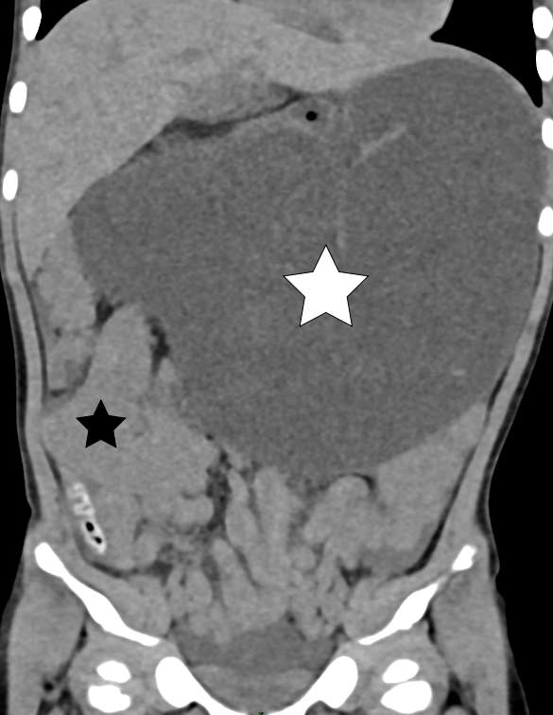
Fig. 7. Non-contrast CT of case 4 revealed marked gastrectasis (white star) and an abnormal splenic location (black star).
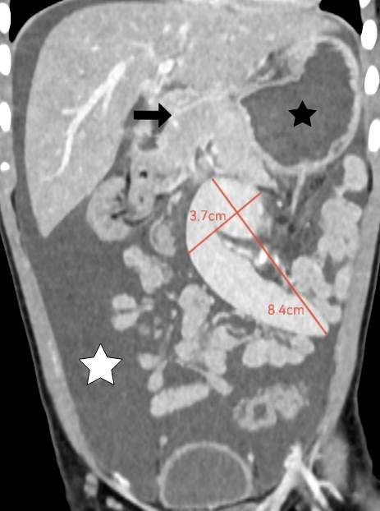
Fig. 8. Enhanced CT scan of Case 4 revealed extensive peritoneal and pelvic effusion (white star), axial torsion of the stomach (black star), and the spleen positioned within the left mid-abdomen. The splenic parenchyma demonstrated preserved enhancement without evidence of infarction. The spleen measured 8.4 cm in length and 3.7 cm in width. The pancreas (black arrow) was situated anterior and to the right of the stomach.
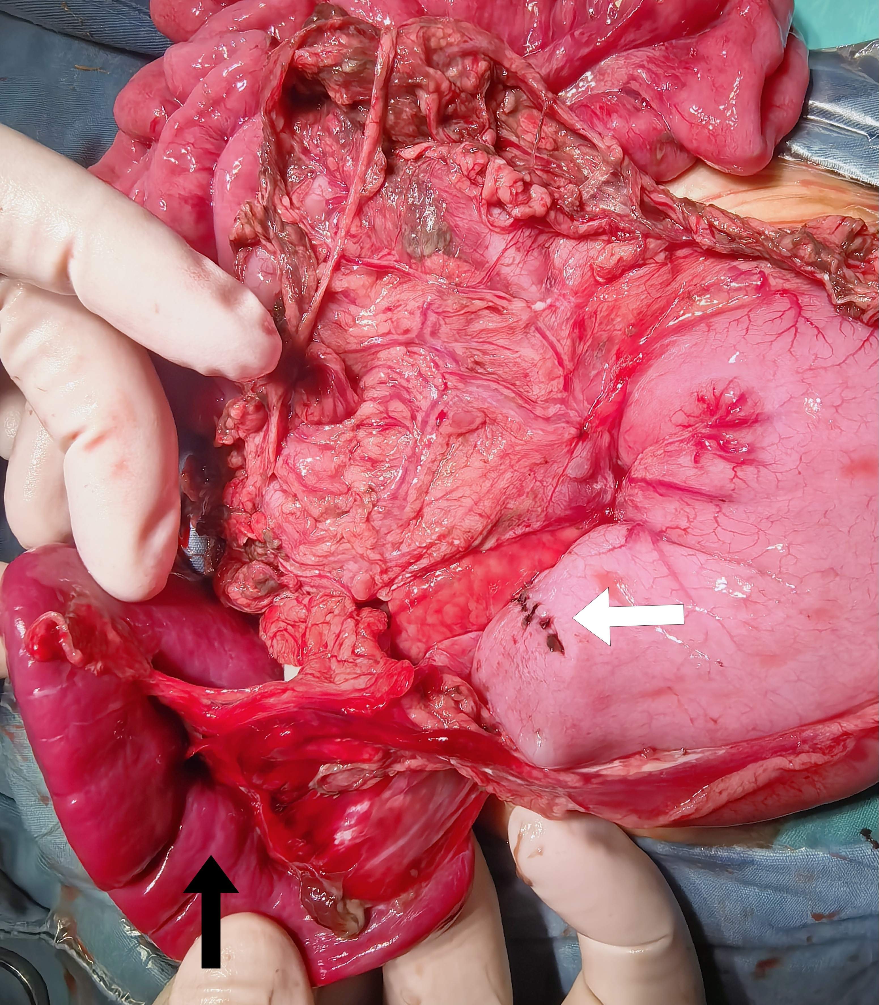
Fig. 9. Case 4 demonstrated a 2-cm perforation located on the posterior wall of the gastric antrum, which has been surgically repaired (white arrow). The spleen exhibits an absence of ligation (black arrow).

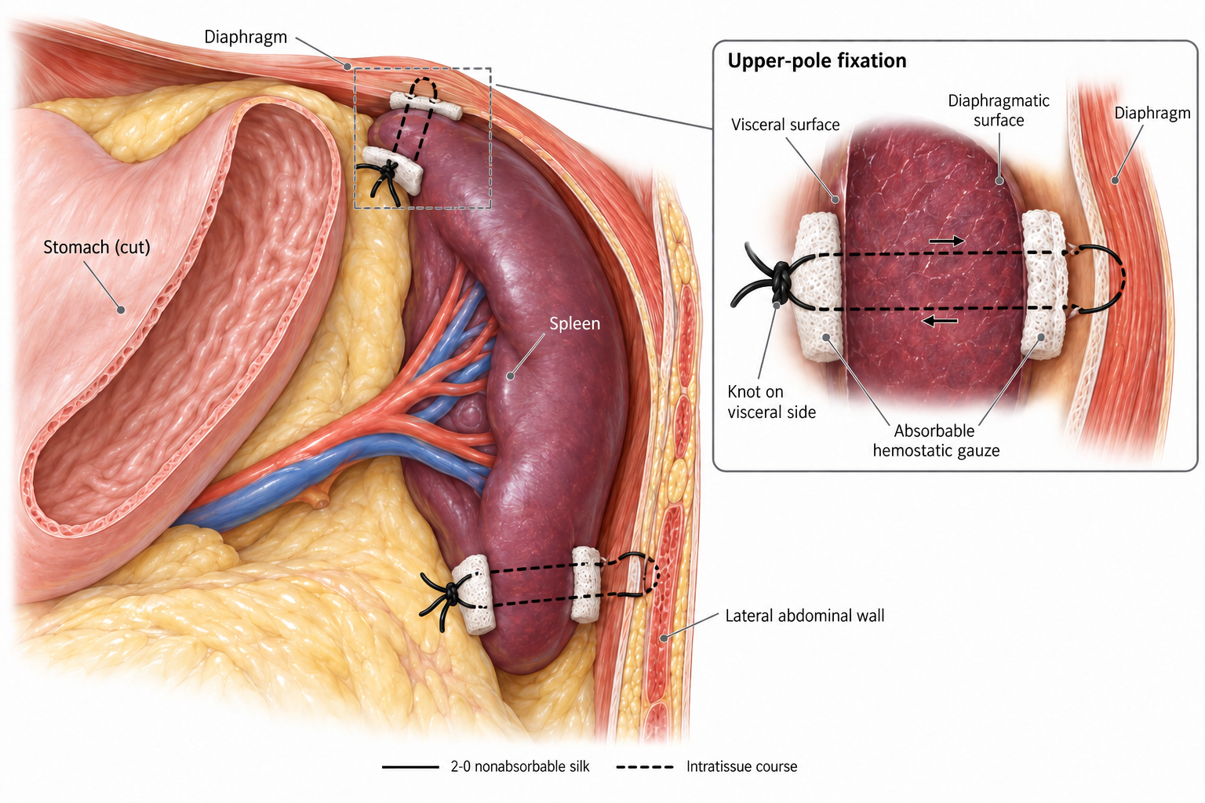
Fig. 10. Reinforced suture fixation technique for the superior and inferior splenic poles
Fig. 11. Non-contrast CT of Case 5 demonstrated an enlarged spleen with heterogeneous parenchymal density located in the anterior lower abdomen and pelvis (black star), a whirl sign formed by the spiraling splenic vessels (black arrow), and perisplenic exudation with free fluid (white star).
Fig. 12. Intraoperative findings in Case 5: the wandering spleen was markedly congested and dark purple, and the splenic pedicle was twisted through approximately 720° (white arrow).

- Results
This study performed a retrospective analysis of five cases of wandering spleen. The cohort comprised two female and three male patients, with ages at initial presentation ranging from 2.75 years to 13.08 years. Detailed clinical data are summarized in Table 1. The five pediatric patients underwent a total of ten clinical visits at our institution: Case 1 and Case 2 each had two visits, Case 3 required four visits, and Case 4 and Case 5 each attended once. The mean interval from initial presentation to splenic surgery for the first three cases was 32 months; Case 5 had been managed as acute gastritis at another hospital one week before presentation. Cases 1 and 2 developed splenic infarction during the disease course, ultimately necessitating total splenectomy. Case 3 underwent laparoscopic partial splenectomy with splenopexy due to partial splenic infarction; however, recurrence of wandering spleen occurred one month postoperatively, requiring repeat laparoscopic total splenectomy with splenic autotransplantation. Although Case 4 did not develop splenic infarction, severe complications including gastric volvulus and gastric perforation ensued, ultimately requiring gastric perforation repair and reinforced suture fixation of the splenic poles. Case 5 presented with a 720° torsion of the splenic pedicle and established splenic necrosis, and underwent open total splenectomy with ligation of the splenic artery. None of the four children who underwent total splenectomy developed postoperative complications such as overwhelming post-splenectomy infection, thromboembolic events, or pulmonary hypertension. All four cases exhibited postoperative thrombocytosis, which gradually normalized following oral dipyridamole therapy. Case 4 recovered satisfactorily after reinforced splenopexy, with the most recent follow-up at 13 months after surgery demonstrating a normally positioned spleen and no recurrence of abdominal pain, distension, or vomiting.

Table 1
Clinical data of the 5 pediatric patients (M, Male; F, Female; U, Ultrasound; CT, Computed tomography; PC, Platelet count; WS, Wandering spleen)
Case | Sex | Visit order | Age | Clinical presentation | Accessory examination | Treatment (conservative or surgical) | Diagnosis | Operative approach | Operative method | Prognosis
1 | M | 1 | 3.75 years | Abdominal pain for 2 days | U: WS with preserved splenic perfusion.  PC: 198×10⁹/L(normal) | Conservative treatment for 5 days | WS | None | None | Readmitted for abdominal pain 16 months later
 |  | 2 | 5.08 years | Abdominal pain with fever for 1 day | CT: WS with torsion of the splenic pedicle and splenic infarction.  PC: 428×10⁹/L (elevated) | Surgery | WS and splenic infarction | Laparotomy | Total splenectomy | Elevated PC
2 | F | 1 | 5.5 years | Abdominal pain for 2 days | CT: WS with torsion of the splenic pedicle and absence of infarction.  PC: 125×10⁹/L(normal) | Conservative treatment for 7 days | WS | None | None | Readmitted for abdominal pain 19 months later
 |  | 2 | 7.08 years | Abdominal pain for 1 day | CT: WS with torsion of the splenic pedicle and splenic infarction.  PC: 525×10⁹/L (elevated) | Surgery | WS and splenic infarction | Laparoscopy → Laparotomy | Total splenectomy | Elevated PC
3 | F | 1 | 4.5 years | Abdominal pain with vomiting for 1 day | U: WS with marked gastrectasis.  PC: 212×10⁹/L (normal) | Conservative treatment for 6 days | WS and gastrectasis | None | None | Readmitted for abdominal pain 26 months later
 |  | 2 | 6.67 years | Abdominal pain with vomiting for 2 days | CT: Marked gastrectasia, WS and absence of infarction. PC: 236×10⁹/L (normal) | Conservative treatment for 5 days | WS and gastrectasis | None | None | Readmitted for abdominal pain 36 months later
 |  | 3 | 9.67 years | Intermittent abdominal pain for 9 days | CT: WS with partial infarction.  PC: 172×10⁹/L (normal) | Surgery | WS and partial splenic infarction | Laparoscope | Partial splenectomy,splenopexy | Readmitted for abdominal pain 1 month later
 |  | 4 | 9.75 years | Abdominal pain for 2 days | CT: WS and pancreatic ectopia.  PC:152×10⁹/L (normal). | Surgery | Recurrent WS | Laparoscope | Total splenectomy, splenic transplantation | Elevated PC
4 | M | 1 | 2.75 years | Abdominal distension for 2 hours | CT: WS with torsion of the splenic pedicle, gastric volvulus, extensive peritoneal and pelvic effusions, and pancreatic ectopia.  PC: 177×10⁹/L (normal) | Surgery | WS and gastric perforation | Laparotomy | Reinforced splenopexy, repair of gastric perforation | Well
5 | M | 1 | 13.08 years | Abdominal pain for 18 hours | CT: WS with torsion of the splenic pedicle, whirl sign, and splenic necrosis.  PC: ___×109/L (normal) | Surgery | WS and splenic necrosis | Laparotomy | Total splenectomy, splenic artery ligation | Elevated PC

5. Discussion
Wandering spleen is an uncommon clinical condition primarily arising from congenital anomalies, including dysplasia of the gastric dorsal mesentery and the absence or malformation of normal splenic suspensory ligaments. This anatomical predisposition renders individuals susceptible to splenic pedicle torsion, which exhibits a higher incidence among young females and pediatric patients. Statistical analysis of 197 pediatric cases revealed a prevalence of 59% in girls and 40% in boys, with a median age of 8 years [4]. In the present series, the male-to-female ratio was 1:1, with a median age of 5 years.
The clinical manifestations of wandering spleen may include abdominal pain, nausea, vomiting, fever, constipation, gastric variceal hemorrhage, and urinary symptoms. Chronic intermittent abdominal pain or acute abdominal pain constitutes the most prevalent clinical presentation. The characteristics of the abdominal pain typically correlate with the degree and rapidity of torsion involving the splenic pedicle. Chronic intermittent pain frequently suggests mild or intermittent torsion, manifesting as relatively mild yet protracted and recurrent symptoms that significantly impair quality of life. Acute splenic pedicle torsion typically presents as sudden, severe abdominal pain accompanied by gastrointestinal symptoms such as nausea and vomiting. This condition progresses rapidly and may precipitate splenic ischemic necrosis without prompt intervention. In Cases 1-3, all patients exhibited a history of chronic recurrent abdominal pain prior to surgery, hypothesized to be associated with mild splenic pedicle torsion. However, Cases 1 and 2 presented with acute abdominal pain during subsequent evaluations. Both imaging studies (Fig. 2) and intraoperative findings confirmed acute torsion with splenic necrosis, necessitating total splenectomy. Case 3 also demonstrated partial splenic infarction during the third assessment and ultimately required surgical intervention. Reviewing the treatment course, initial parental preference for non-operative management resulted in delayed intervention for the first three cases. Non-surgical management failed to arrest disease progression, and all three children were re-admitted due to symptom exacerbation, undergoing surgery following an average of 32 months of conservative management. A comparable delay occurred in Case 5, in whom an episode one week before presentation had been managed as acute gastritis at another institution; by the time the correct diagnosis was established the spleen had undergone 720° torsion with established necrosis. Consequently, these findings support performing splenopexy promptly upon diagnosis of wandering spleen in children, including during asymptomatic phases, to prevent secondary splenic necrosis and adjacent organ injury resulting from torsion.
Regarding diagnosis, wandering spleen exhibits characteristic imaging findings. Contrast-enhanced CT provides definitive delineation of splenic location and dimensions, the degree of vascular pedicle torsion, parenchymal perfusion status, thrombosis within the splenoportal venous system, and potential involvement of adjacent organs (including pancreatic torsion, gastric volvulus, or compression of hollow viscera such as the bladder or intestines) [5,6]. The whirl sign, produced by the spiraling splenic vessels around the twisted pedicle, is a particularly useful diagnostic feature and was the finding that established the diagnosis on non-contrast CT in Case 5. Ultrasonography, due to its non-invasive nature and accessibility, may serve as an initial screening modality, although its diagnostic accuracy is comparatively limited. In the present study, all pediatric patients received a definitive preoperative diagnosis. Wang et al. [7] reported that preoperative thrombocytosis may serve as a predictive indicator for splenic infarction. In cases of acute severe splenic torsion resulting in infarction, the patient enters a functional splenectomy state, potentially leading to the development of secondary reactive thrombocytosis. The five pediatric cases included in this study presented for a total of ten clinical encounters at our institution: Cases 1 and 2 underwent total splenectomy due to splenic infarction, with both instances preceded by significant preoperative thrombocytosis, whereas during the encounters in which splenic viability was preserved the platelet counts remained within normal ranges (Table 1). Case 5, however, presented with an acute 18-hour history and established splenic necrosis despite a normal preoperative platelet count. This observation indicates that reactive thrombocytosis reflects a period of functional asplenia of sufficient duration rather than the presence of infarction per se, and that a normal platelet count should therefore not be used to exclude splenic infarction or necrosis in a child with suspected torsion.
Wandering spleen presents a significant risk of torsion, potentially progressing to splenic infarction and necessitating urgent surgical intervention. With increasing recognition of splenic immune functions and documented reports of fulminant post-splenectomy infections, splenic preservation has emerged as the cornerstone therapeutic strategy for wandering spleen, particularly in pediatric populations. Splenectomy is indicated in cases of ischemic infarction, whereas splenopexy constitutes the primary approach for viable spleens [8]. The selection of specific surgical techniques—including partial splenectomy, total splenectomy, splenic autotransplantation, gastropexy, and splenopexy—should be guided by intraoperative findings.
Partial splenectomy is indicated for localized splenic lesions when partial preservation of splenic function is feasible, as it mitigates the impact on pediatric immune function. For children with wandering spleen complicated by splenic cysts, splenic cyst resection combined with residual splenopexy may be performed [9,10]. In this study, Case 3 developed partial splenic infarction during the third hospitalization and underwent laparoscopic partial splenectomy combined with splenopexy. Literature reports indicate that indications for splenectomy in splenic torsion include splenic infarction, splenomegaly, hypersplenism, splenic vascular thrombosis, and splenic rupture [11,12]. Cases 1 and 2 underwent total splenectomy due to splenic infarction. Case 3, hospitalized for the fourth time due to recurrent wandering spleen, did not exhibit evidence of splenic necrosis but was scheduled for total splenectomy due to significant splenic enlargement and anticipated poor outcomes following repeat splenopexy. We now believe that the three-incision retroperitoneal pouch or reinforced suture fixation technique for the superior and inferior splenic poles described subsequently could potentially preserve splenic function in this patient. Splenic autotransplantation involves the transplantation of viable autologous splenic tissue into an omental pouch [13]. Given that the total splenic tissue resected in Case 3 demonstrated viability, autotransplantation was performed.
Wandering spleen may involve adjacent organs, resulting in complications such as pancreatic torsion, gastric volvulus, or gastrointestinal and urinary tract obstruction secondary to direct compression. Standard management involves reduction of the splenic and pancreatic torsion followed by splenopexy or splenectomy; pancreatic injury or subsequent complications are typically not observed following this approach [14-16]. Distal pancreatectomy is indicated only in cases where torsion has resulted in necrosis of the pancreatic tail [7]. Within the present cohort, both Case 3 and Case 4 demonstrated abnormal pancreatic positioning intraoperatively, yet neither developed pancreatitis nor pancreatic necrosis. Postoperative imaging confirmed restoration of normal pancreatic anatomy, with no associated complications identified. Regarding the management of wandering spleen complicated by gastric volvulus, the optimal surgical strategy—whether splenopexy alone or combined with gastropexy—remains controversial. Previous reports indicate successful outcomes with both isolated splenopexy [17] and isolated gastropexy [18], while other studies advocate combined splenopexy and gastropexy [4,19]. Currently, no standardized surgical protocol exists for this combined pathology. In this series, patients presenting with gastric volvulus (Case 3 and Case 4) underwent splenic surgery only (total splenectomy for Case 3 and splenopexy for Case 4). No recurrence of gastric volvulus or related complications was documented during follow-up. Additionally, wandering spleen can exert compressive effects on adjacent viscera, potentially causing complications such as pancreatitis or gastric outlet obstruction due to direct compression [20,21], or hydronephrosis secondary to ureteral compression [22]. None of these complications manifested in the current cohort.
Splenopexy encompasses a diverse array of methods, including mesh wrapping, construction of an retroperitoneal pouch, and suturing the spleen to the diaphragm and posterior abdominal wall. While these techniques can effectively achieve splenopexy, the selection of a specific procedure necessitates comprehensive evaluation of factors such as spleen size, perisplenic anatomical characteristics, and the surgeon's technical preferences. Most mesh-based splenopexy involve wrapping the spleen with synthetic mesh and securing it to the peritoneum or diaphragm [16,23,24]; some investigators have also utilized autologous omentum for this purpose [25,26]. However, in pediatric patients with significant splenomegaly, these techniques may pose considerable challenges due to difficulties in fully accommodating the spleen within the mesh and constraints in laparoscopic working space. Furthermore, the application of synthetic mesh carries potential risks of infection and foreign body rejection. Another commonly employed splenopexy is the construction of an retroperitoneal pouch. Methods for creating the retroperitoneal space vary, encompassing balloon dilation [27-29], saline injection [30], and blunt dissection [31]. Nevertheless, this approach may result in serious postoperative complications, such as splenic ischemia or even splenic infarction secondary to compression exerted by the retroperitoneal pouch. In cases of splenomegaly, retroperitoneal pouch fixation is often technically demanding due to challenges including the inability to form a sufficiently large retroperitoneal pouch, difficulties in laparoscopic manipulation of an enlarged spleen, risks of iatrogenic splenic laceration and hemorrhage, and prolonged operative time. Under these circumstances, some investigators ultimately resort to splenectomy [7]. In the current case series, Patient 3 encountered similar difficulties during the initial procedure, which precluded retroperitoneal pouch fixation and led to the adoption of a simplified suturing technique for splenopexy. To address this issue, some scholars have advocated partial splenectomy combined with splenopexy for managing cases with splenomegaly and partial splenic infarction [32,33]; others have employed a three-incision retroperitoneal pouch fixation in the treatment of enlarged wandering spleen [30,34].
Based on the preceding analysis, this study presents a novel splenopexy technique, designated as reinforced suture fixation technique for the superior and inferior splenic poles. In Case 3, the initial suture fixation procedure was technically uncomplicated, involving approximation of the splenic capsule to the diaphragm and lateral peritoneum reinforced with Hem-o-lock clips. Due to the superficial fixation, wandering spleen recurrence occurred within one month postoperatively. To address this recurrence, Case 4 underwent the novel reinforced splenopexy: 2-0 silk sutures were placed through the full thickness of the splenic parenchyma at both the superior and inferior poles, substantially augmenting fixation strength. Additionally, absorbable hemostatic gauze was applied to both diaphragmatic and visceral splenic surfaces to mitigate suture cutting injury, control intraoperative hemorrhage, and promote local adhesion formation. This technique is straightforward to perform, independent of splenic dimensions, and obviates the technical challenges associated with retroperitoneal pouch construction, rendering it particularly suitable for splenomegaly or cases of failed prior splenopexy. The study further posits that splenic enlargement may regress following fixation due to improved hemodynamics, and pediatric spleens may undergo physiological enlargement with development. However, given the spleen's significant elasticity, viscoelastic properties, and regenerative capacity, a stable anatomical position is more likely to be established during volumetric changes. Consequently, this fixation technique is unlikely to be compromised by alterations in splenic size; conversely, as the spleen undergoes morphological adaptation, adhesion strength and structural stability within the fixation region may be progressively augmented.
This study has several limitations: the small sample size and the limited duration of follow-up after splenopexy preclude a comprehensive assessment of the long-term recurrence rate of wandering spleen and of the long-term developmental impact of splenopexy. In particular, the reinforced suture fixation technique was applied in a single patient, and the present report should therefore be regarded as a preliminary technical description rather than a validated standard. Furthermore, the absence of multicenter collaboration may have introduced selection bias. Future investigations should prioritize expanding the cohort size, prolonging the follow-up duration, and integrating advanced imaging modalities to dynamically monitor splenic positional and morphological changes, thereby rigorously validating the safety and efficacy of the described splenopexy technique.

6. Conclusion
Imaging examinations are essential for the diagnosis of pediatric wandering spleen. Early splenopexy is recommended upon diagnosis to prevent splenic torsion, necrosis, and adjacent organ injury. The reinforced suture fixation technique for the superior and inferior splenic poles demonstrates safety and feasibility. This approach could be considered for giant wandering spleen; however, its efficacy requires further clinical validation.

Consent
Given the retrospective nature of data collection, no informed consent was deemed necessary by the ethics committee. No identifiable information is included in the manuscript.

Sources of funding
No fundings.

Author contributions
Jun Shu designed the study conception, acquired the data and prepared the manuscript. Jun Shu also analyzed and interpretated the data. Fei Peng, Ji Wang drafted the manuscript. Jun Yang, Hongqiang Bian reviewed the manuscript. All authors read and approved the final manuscript.

Conflicts of interest disclosure
The authors report no conflicts of interests.

Research registration unique identifying number (UIN)
Not applicable.

Provenance and peer review
Not commissioned, externally peer-reviewed.

Data availability statement
Datasets generated during and/or analyzed during the current study are available upon reasonable request.

Acknowledgements
We cordially thank Yuji Wang, Hao Zheng and Kai Chen for their excellent technical support. We thank the Biostatistics Unit of the Huazhong University of Science & Technology for their expert advice.

References:
[1] Gashaw Wubie A, Yirga B, Goedert MH. Splenic infarction following torsion of wandering spleen involving pancreatic tail successfully managed in resource limited setting: a case report. J Med Case Rep 2025;19:41.
[2] Cui Q, Xu X, Li C, Tang L. Wandering spleen combined with pedicle torsion and splenic infarction: a rare case report and literature review. Front Pediatr 2024;12:1429490.
[3] Al Blooshi M, Aboelkheir A, Hiremath A, Jaber G, AlMarzouqi M. The enigmatic wandering spleen: managing three cases in a tertiary setting. BMC Pediatr 2025;25:631.
[4] Ganarin A, Fascetti Leon F, La Pergola E, Gamba P. Surgical approach of wandering spleen in infants and children: a systematic review. J Laparoendosc Adv Surg Tech A 2021;31:468-77.
[5] Gulati M, Suman A, Satyam, Garg A. Torsion of wandering spleen and its adherence to the right ovary - an unusual cause of recurrent pain abdomen. J Radiol Case Rep 2020;14:10-8.
[6] Lombardi R, Menchini L, Corneli T, Magistrelli A, Accinni A, Monti L, et al. Wandering spleen in children: a report of 3 cases and a brief literature review underlining the importance of diagnostic imaging. Pediatr Radiol 2014;44:279-88.
[7] Wang Z, Peng C, Wu D, Wang K, Chen Y. Diagnosis and treatment of splenic torsion in children: preoperative thrombocytosis predicts splenic infarction. BMC Pediatr 2022;22:440.
[8] Fiquet-Francois C, Belouadah M, Ludot H, Defauw B, Mcheik JN, Bonnet JP, et al. Wandering spleen in children: multicenter retrospective study. J Pediatr Surg 2010;45:1519-24.
[9] Upadhyaya P, St Peter SD, Holcomb GWR. Laparoscopic splenopexy and cystectomy for an enlarged wandering spleen and splenic cyst. J Pediatr Surg 2007;42:E23-7.
[10] Ikeda T, Hosokawa T, Goto S, Hashimoto M, Nagasaki E, Masuko T. Successful laparoscopic-assisted partial splenectomy and splenopexy with umbilical approach to wandering spleen with an enlarged cyst in a pediatric patient. J Surg Case Rep 2022;2022:rjac483.
[11] Radillo L, Taddio A, Ghirardo S, Bramuzzo M, Pederiva F, Maschio M, et al. The great pretender: pediatric wandering spleen: two case reports and review of the literature. Pediatr Emerg Care 2016;32:619-22.
[12] Masroor M, Sarwari MA. Torsion of the wandering spleen as an abdominal emergency: a case report. BMC Surg 2021;21:289.
[13] Katsura S, Kawamura D, Harada E, Enoki T, Hamano K. Single-incision laparoscopic splenectomy and splenic autotransplantation for an enlarged wandering spleen with torsion. European J Pediatr Surg Rep 2014;2:23-5.
[14] Colombo F, D'Amore P, Crespi M, Sampietro G, Foschi D. Torsion of wandering spleen involving the pancreatic tail. Annals of medicine and surgery (2012) 2019;50:10-3.
[15] Alqadi GO, Saxena AK. Is laparoscopic approach for wandering spleen in children an option? J Minim Access Surg 2019;15:93-7.
[16] Torri F, Parolini F, Vanzetti E, Milianti S, Cheli M, Alberti D. Urgent laparoscopic mesh splenopexy for torsion of wandering spleen and distal pancreas: a case report. Asian J Endosc Surg 2015;8:350-3.
[17] Garcia JA, Garcia-Fernandez M, Romance A, Sanchez JC. Wandering spleen and gastric volvulus. Pediatr Radiol 1994;24:535-6.
[18] François-Fiquet C, Belouadah M, Chauvet P, Lefebvre F, Lefort G, Poli-Merol ML. Laparoscopic gastropexy for the treatment of gastric volvulus associated with wandering spleen. Journal of laparoendoscopic & advanced surgical techniques. Part A 2009;19 Suppl 1:S137-9.
[19] Okazaki T, Ohata R, Miyano G, Lane GJ, Takahashi T, Yamataka A. Laparoscopic splenopexy and gastropexy for wandering spleen associated with gastric volvulus. Pediatr Surg Int 2010;26:1053-5.
[20] Magno S, Nanni L, Retrosi G, Cina A, Gamba PG. An unusual case of acute pancreatitis and gastric outlet obstruction associated with wandering spleen treated by laparoscopic splenopexy. Journal of laparoendoscopic & advanced surgical techniques. Part A 2011;21:467-70.
[21] Sanchez R, Lobert P, Herman R, O'Malley R, Mychaliska G. Wandering spleen causing gastric outlet obstruction and pancreatitis. Pediatr Radiol 2010;40 Suppl 1:S89-91.
[22] EMIR H, YESILDAG E, YEKER Y, SÖYLET Y, SENYÜZ OF. A case of wandering spleen causing urinary symptoms after correction of a posterolateral diaphragmatic hernia. Pediatr Surg Int 2000;16:602-3.
[23] Cohen O, Baazov A, Samuk I, Schwarz M, Kravarusic D, Freud E. Emergencies in the treatment of wandering spleen. Isr Med Assoc J 2018; 20:354-7.
[24] Morgan S, Glenn I, Soldes O. Laparoscopic splenopexy for wandering spleen, a video demonstration of technique by encircling the spleen with polyglactin 910 woven mesh. Surg Endosc 2017;31:5427-8.
[25] Goyal RB, Gupta R, Prabhakar G, Mathur P, Mala TA. Salvage splenopexy for torsion of wandering spleen in a child. APSP J Case Rep 2014;5:4.
[26] Lacreuse I, Moog R, Kauffmann I, Méfat L, Bailey C, Becmeur F. Laparoscopic splenopexy for a wandering spleen in a child. J Laparoendosc Adv Surg Tech 2007;17:255-7.
[27] Martínez-Ferro M, Elmo G, Laje P. Laparoscopic pocket splenopexy for wandering spleen: a case report. J Pediatr Surg 2005;40:882-4.
[28] Schaarschmidt K, Lempe M, Kolberg-Schwerdt A, Schlesinger F, Hayek I, Jaeschke U. The technique of laparoscopic retroperitoneal splenopexy for symptomatic wandering spleen in childhood. J Pediatr Surg 2005;40:575-7.
[29] Fukuzawa H, Urushihara N, Ogura K, Miyazaki E, Matsuoka T, Fukumoto K, et al. Laparoscopic splenopexy for wandering spleen: extraperitoneal pocket splenopexy. Pediatr Surg Int 2006;22:931-4.
[30] Umeda S, Kimura K, Takama Y, Yamauchi K, Yonekura T. Laparoscopic retroperitoneal splenopexy for wandering spleen: a novel technique using a three-incision retroperitoneal pouch. Asian J Endosc Surg 2021;14:644-7.
[31] Awan M, Gallego JL, Al Hamadi A, Vinod VC. Torsion of wandering spleen treated by laparoscopic splenopexy: a case report. Int J Surg Case Rep 2019;62:58-61.
[32] Esposito C, Settimi A, Centonze A, Damiano R, Maglio P, Esposito G. Enlarged wandering spleen treated with hemisplenectomy and fixation of the residual spleen. Pediatr Surg Int 2005;21:488-90.
[33] Fonseca AZ, Ribeiro MJ, Contrucci O. Torsion of a wandering spleen treated with partial splenectomy and splenopexy. The Journal of emergency medicine 2013;44:e33-6.
[34] Zivkovic SM. Sutureless "button and hole" splenopexy. Pediatr Surg Int 1998;13:220-2.

